WHITE BAND ASSOCIATES
CYBER SECURITY INTERNSHIP PROGRAMME
Cyber Security Task 02
CIA Triad & Risk Assessment

Prepared By | Pratiksha Vishwakarma
Programme | Cyber Security Internship – Task 02
Focus Areas | CIA Triad · Case Study · Risk Assessment · Threat Identification · Recommendations · Consultant Report
Case Study | WannaCry Ransomware Attack (May 2017)
Role Context | Cyber Security Intern

Part A Understanding the CIA Triad
The CIA Triad — Confidentiality, Integrity, and Availability — is the foundational model underpinning every security policy, control, and architecture decision in information security. All three pillars must be balanced; over-prioritising one at the expense of another creates exploitable gaps. The sections below define each principle, explain its importance, and anchor it with a documented real-world example.

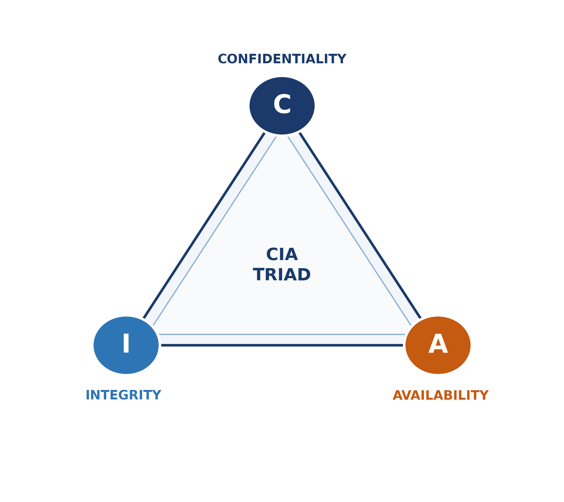
Figure 1 – The CIA Triad: the three interdependent pillars of information security

A.1 – Confidentiality
Definition
Confidentiality is the principle of ensuring that information is accessible only to those who are authorised to access it. It is enforced through mechanisms such as encryption, role-based access control (RBAC), multi-factor authentication, and the principle of least privilege — granting each user or process only the minimum permissions required to perform their function.
Why It Is Important
Organisations hold vast quantities of sensitive data — personal records, financial information, intellectual property, medical histories, and examination results. A breach of confidentiality exposes this data to unauthorised parties, leading to identity theft, financial fraud, reputational damage, regulatory penalties under legislation such as India’s Digital Personal Data Protection Act 2023 or the EU’s GDPR, and loss of stakeholder trust. For institutions such as colleges, confidentiality is both a legal obligation and a duty of care to students, faculty, and staff.
Real-World Example
In 2017, the Equifax data breach exposed the Social Security numbers, birth dates, addresses, and credit card details of approximately 147 million individuals. Attackers exploited an unpatched Apache Struts vulnerability to gain unrestricted access to internal databases. The breach was a catastrophic failure of confidentiality controls — one that cost Equifax over $700 million in settlements and permanently eroded public trust in the company.

A.2 – Integrity
Definition
Integrity ensures that data remains accurate, complete, and unaltered except through authorised processes. It guarantees that information has not been tampered with — whether by a malicious insider, an external attacker, or an accidental system error — during storage, processing, or transmission. Controls include cryptographic hashing (SHA-256, MD5), digital signatures, checksums, audit logs, and version control systems.
Why It Is Important
Without integrity, organisations cannot rely on the accuracy of their own data. Financial records can be falsified, examination results manipulated, software updates weaponised, and audit trails erased. Healthcare systems that lose integrity may deliver incorrect treatments; financial institutions that lose integrity may process fraudulent transactions. At the supply-chain level, a single compromised software component can introduce vulnerabilities into thousands of downstream organisations simultaneously.
Real-World Example
The 2020 SolarWinds supply-chain attack saw threat actors insert malicious code (SUNBURST backdoor) into a legitimate, digitally-signed software update for SolarWinds Orion. Because the update passed standard integrity checks and was delivered through trusted channels, approximately 18,000 organisations — including multiple U.S. federal agencies — unknowingly installed compromised software, demonstrating an integrity failure at the most fundamental level of the software supply chain.

A.3 – Availability
Definition
Availability ensures that information, systems, and services are accessible to authorised users whenever they are legitimately required. It is maintained through hardware redundancy, load balancing, disaster recovery planning, regular maintenance, sufficient bandwidth provisioning, DDoS mitigation, and robust backup and failover mechanisms.
Why It Is Important
Modern organisations — hospitals, banks, universities, utilities, and e-commerce platforms — depend on continuous, uninterrupted access to their systems. Downtime translates directly into lost revenue, operational paralysis, service failures, and in critical sectors such as healthcare, direct risk to human life. Availability is frequently the primary target of ransomware operators, hacktivists, and nation-state actors seeking to cause maximum disruption or extort payment under threat of sustained outage.
Real-World Example
The 2021 Colonial Pipeline ransomware attack forced the company to shut down pipeline operations supplying approximately 45% of fuel to the U.S. East Coast. The precautionary operational shutdown — taken to prevent ransomware from spreading to operational technology — caused widespread fuel shortages, panic buying, and a declaration of a state of emergency in several U.S. states. The company ultimately paid a ransom of approximately $4.4 million in Bitcoin to restore availability.

A.4 – CIA Triad Comparison Table
The table below consolidates all three CIA Triad principles for quick comparative reference.

Principle | Core Goal | Key Controls | Real-World Example | Failure Consequence
Confidentiality | Prevent unauthorised disclosure of data | Encryption, RBAC, MFA, least privilege, data masking | Equifax Data Breach (2017) – 147M records exposed | Identity theft, fraud, regulatory fines, reputational loss
Integrity | Prevent unauthorised alteration of data | Hashing, digital signatures, audit logs, checksums, version control | SolarWinds Supply-Chain Attack (2020) – SUNBURST backdoor in signed update | Corrupted records, falsified data, trojanised software
Availability | Ensure reliable, timely access to data and systems | Redundancy, backups, failover, DDoS protection, disaster recovery | Colonial Pipeline Attack (2021) – fuel supply halted | Downtime, revenue loss, service failure, public harm

“The CIA Triad is not a checklist — it is a continuous balancing act. Strengthen one pillar without the others, and the structure remains vulnerable.”

Part B Real-World Case Study – WannaCry Ransomware
The WannaCry ransomware attack of May 2017 remains one of the most significant and far-reaching cyberattacks in history. The following case study examines what happened, which elements of the CIA Triad were violated, the global impact, and how the attack could have been prevented.

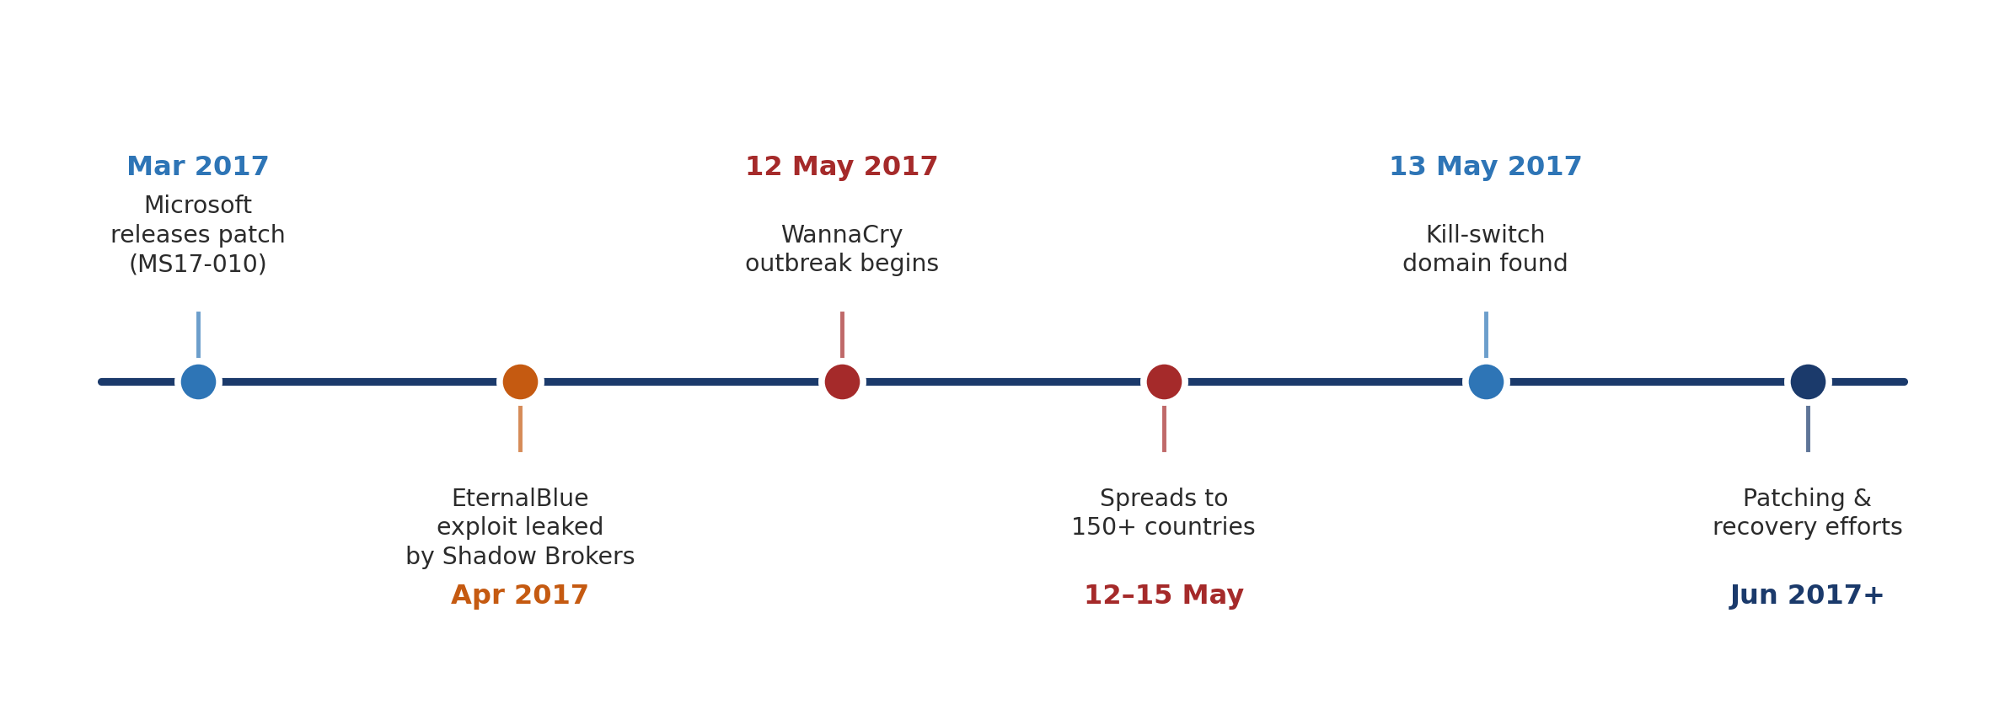
Figure 2 – WannaCry Attack Timeline: from vulnerability disclosure to global outbreak

B.1 – What Happened?
In March 2017, Microsoft released a critical security patch (MS17-010) to address a severe vulnerability in the Windows SMB (Server Message Block) protocol. The vulnerability had been discovered by the NSA and was secretly held as a cyberweapon. In April 2017, the hacking group Shadow Brokers leaked the exploit publicly — naming it EternalBlue.

On 12 May 2017, a ransomware worm known as WannaCry was released into the wild, leveraging EternalBlue to scan networks for vulnerable Windows systems and spread autonomously without any user interaction — unlike most ransomware which requires a victim to click a malicious link or attachment. Once a machine was infected, WannaCry encrypted the victim’s files and displayed a ransom note demanding $300–$600 in Bitcoin in exchange for a decryption key.

A critical turning point came on 13 May 2017, when a British security researcher (Marcus Hutchins) discovered that WannaCry queried a specific unregistered domain before executing. He registered the domain for approximately $10, which acted as an accidental kill-switch and slowed the worm’s propagation. However, by that point, the damage was done.

B.2 – Which Part of the CIA Triad Was Affected?

CIA Pillar | Affected? | How It Was Impacted
Confidentiality | Partially | WannaCry’s primary mechanism was encryption rather than data theft. However, some variants exfiltrated data, and access to sensitive files was denied to authorised users.
Integrity | Yes | Encrypted files were rendered inaccessible and effectively corrupted from the user’s perspective. File system integrity was destroyed on infected systems.
Availability | Severely | This was the primary CIA violation. Hundreds of thousands of systems were rendered completely inoperable. Hospitals cancelled procedures; factories halted production lines; banks suspended operations.

B.3 – What Was the Impact?
The scale of the WannaCry attack was unprecedented. Within 72 hours of its release it had spread to over 200,000 systems across 150 countries, causing an estimated $4–8 billion in damages globally. Key impacts included:

- NHS (UK): Over 80 National Health Service trusts were affected. Thousands of appointments and non-emergency surgeries were cancelled. Ambulances were diverted from affected hospitals. Estimated cost to the NHS exceeded £92 million.
- Telefonica (Spain): Major telecommunications provider suffered significant internal system outages.
- FedEx / TNT Express: Logistics operations were disrupted globally; TNT reported losses of approximately $400 million.
- Renault-Nissan: Multiple manufacturing plants across Europe and India were forced to halt production.
- Russian Interior Ministry & Central Bank: Thousands of internal computers were infected, demonstrating that even government entities were vulnerable.
- Critical infrastructure: Rail systems, energy companies, and telecoms in multiple countries reported infections.

B.4 – How Could It Have Been Prevented?
- Apply security patches promptly: MS17-010 was available for two months before the attack. Organisations that had applied the patch were fully protected. A robust patch management programme would have eliminated the attack vector entirely.
- Disable SMBv1: The EternalBlue exploit required SMBv1, a legacy protocol that should have been disabled across all enterprise networks.
- Network segmentation: Isolating systems into separate network segments would have prevented the worm from spreading laterally across entire organisational networks.
- Regular offline backups: Organisations with current, tested, offline backups could restore encrypted data without paying the ransom.
- Intrusion Detection/Prevention Systems (IDS/IPS): Monitoring for anomalous SMB traffic patterns would have detected the worm’s lateral movement and triggered alerts.
- Principle of least privilege: Limiting user and system permissions would have reduced the worm’s ability to access and encrypt files beyond the immediate user’s profile.

Part C Risk Assessment Activity – College Environment
As a Security Analyst for a college, the following risk assessment identifies the ten most critical assets that require protection, the primary threat to each, the potential business impact, and the corresponding risk level. Risk levels are derived from the likelihood and impact matrix illustrated below.

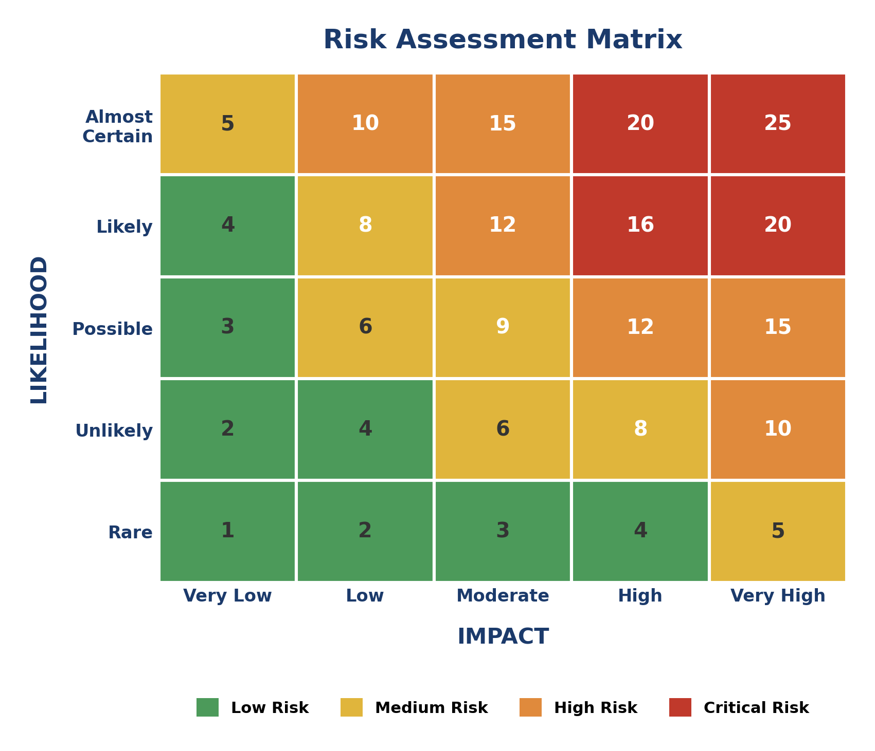
Figure 3 – Risk Assessment Matrix – Risk Level = Likelihood × Impact

C.1 – College Risk Assessment Table

Asset | Primary Threat | Business Impact | Likelihood | Risk Level
Student Records (PII) | Data Breach / Unauthorised Access | High | High | Critical
Examination Data & Results | Insider Threat / Data Manipulation | High | Possible | High
College Network Infrastructure | Ransomware / DDoS Attack | High | Likely | Critical
Faculty & Staff Information | Phishing / Credential Theft | High | Likely | Critical
College Website & Portal | Defacement / SQL Injection | Medium | Possible | High
Financial & Fee Records | Fraud / Unauthorised Modification | High | Unlikely | High
Learning Management System (LMS) | Malware / Ransomware | High | Possible | High
Email Communication System | Phishing / Business Email Compromise | Medium | Likely | High
CCTV & Physical Access Systems | Tampering / Unauthorised Access | Medium | Unlikely | Medium
Backup & Recovery Systems | Ransomware / Deletion Attack | High | Unlikely | High

Analyst Note: Critical assets (Student Records, Network Infrastructure, Faculty Information) require immediate security controls. High-risk assets must be addressed within the next 30–60 days.

C.2 – Risk Register Narrative
Student Records represent the most critical asset given the volume of personally identifiable information (PII) held — names, addresses, national identification numbers, academic history, and financial records. A breach would violate data protection legislation, expose the college to significant liability, and cause lasting harm to thousands of students.

Network Infrastructure is equally critical because a successful ransomware or DDoS attack could render all digital college services simultaneously unavailable — affecting examinations, administration, communications, and remote learning platforms in a single event.

Faculty and Staff Information carries a high risk because spear-phishing attacks targeting teaching staff are a common attack vector; compromised staff credentials provide attackers with trusted internal access from which to pivot into more sensitive systems.

Part D Threat Identification
The five threats below are the most significant risks facing a college environment. Each is explained in plain language with a documented impact scenario and concrete prevention methods.

D.1 – Insider Threat
Description
An insider threat arises when a current or former employee, contractor, student, or trusted third party intentionally or accidentally causes harm to the organisation’s data, systems, or operations. Insiders have legitimate credentials and often understand internal security controls, making them particularly difficult to detect. Insider threats are categorised as malicious (deliberate sabotage or data theft), negligent (careless handling of sensitive data), or compromised (a legitimate account hijacked by an external attacker).
Possible Impact
- Unauthorised exfiltration of student or financial records for personal gain or sale.
- Deliberate manipulation or deletion of examination results or grade data.
- Installation of malware or backdoors by a disgruntled employee before departure.
- Accidental data leaks via misaddressed emails, misconfigured cloud storage, or unsecured devices.
Prevention Methods
- Implement User and Entity Behaviour Analytics (UEBA) to detect anomalous access patterns.
- Apply the principle of least privilege: users should only access data essential to their role.
- Enforce separation of duties for sensitive operations such as grade modification or financial approvals.
- Conduct thorough background checks for staff with access to sensitive systems.
- Maintain detailed audit logs of all data access, modification, and deletion events.

D.2 – Malware
Description
Malware (malicious software) is any software intentionally designed to disrupt, damage, or gain unauthorised access to a computer system. The malware family is broad and includes viruses (self-replicating code that attaches to legitimate programs), trojans (malicious code disguised as legitimate software), worms (self-propagating malware that spreads across networks without user interaction), spyware (software that covertly monitors user activity), adware, and ransomware. Malware typically enters a system via phishing emails, malicious downloads, infected USB drives, or drive-by website downloads.
Possible Impact
- Complete data encryption by ransomware, rendering institutional systems inoperable.
- Theft of credentials, financial data, or examination materials by spyware or keyloggers.
- System instability, data corruption, or permanent loss of files.
- The college network being used as a launchpad for attacks against external organisations (botnet participation).
Prevention Methods
- Deploy and maintain a reputable endpoint detection and response (EDR) solution with real-time scanning.
- Keep all operating systems and applications fully patched and updated.
- Implement email filtering and web proxy controls to block malicious downloads.
- Disable auto-run for removable media and restrict USB port access on college devices.
- Provide regular security awareness training so staff and students recognise malware delivery methods.

D.3 – Phishing
Description
Phishing is a social engineering attack in which a cybercriminal sends fraudulent communications — typically emails, SMS messages (smishing), or voice calls (vishing) — impersonating a trusted entity such as a bank, technology provider, government body, or a college’s own IT department. The goal is to deceive the recipient into revealing login credentials, clicking a malicious link, or downloading a malicious attachment. Spear-phishing targets specific named individuals with personalised content, making it significantly more convincing than generic phishing campaigns.
Possible Impact
- Compromise of staff email accounts, enabling internal phishing campaigns and business email compromise (BEC) fraud.
- Theft of student login credentials for the college portal or LMS.
- Delivery of ransomware or other malware via malicious email attachments.
- Financial fraud through impersonation of college administration requesting payment transfers.
Prevention Methods
- Enforce multi-factor authentication (MFA) on all college systems so stolen credentials alone are insufficient.
- Implement DMARC, DKIM, and SPF email authentication records to prevent domain spoofing.
- Conduct regular phishing simulation exercises and training for all staff and students.
- Deploy an email security gateway to filter suspicious messages before delivery.
- Establish a clear internal reporting process for suspected phishing attempts.

D.4 – Weak Passwords
Description
Weak passwords are credentials that are short, predictable, based on personal information, or reused across multiple services. They are trivially cracked through brute-force attacks (systematically trying all combinations), dictionary attacks (testing common words and phrases), credential stuffing (using username/password pairs leaked in previous breaches), or password spraying (testing a small set of common passwords against many accounts to avoid lockout thresholds). In a college environment, weak passwords are often the initial foothold through which attackers gain access to internal systems.
Possible Impact
- Unauthorised access to student records, examination systems, or financial data.
- Account takeover enabling an attacker to impersonate faculty or administrative staff.
- A single compromised account providing a pivot point for lateral movement through the network.
- Breach of shared or default service accounts that control critical infrastructure.
Prevention Methods
- Enforce a strong password policy: minimum 12 characters, mixing uppercase, lowercase, numbers, and symbols.
- Mandate the use of a college-approved password manager to generate and store complex credentials.
- Implement account lockout policies after a defined number of failed login attempts.
- Require MFA on all accounts, rendering password strength a secondary rather than sole defence.
- Routinely audit accounts against known breached-password databases (e.g. HaveIBeenPwned API).

D.5 – Unpatched Systems
Description
Unpatched systems are computers, servers, network devices, or applications that have not had available security updates applied. Software vendors regularly release patches to correct known vulnerabilities; when these patches are not applied, the vulnerabilities remain exploitable by anyone with knowledge of them — including automated scanning tools used by opportunistic attackers. In a college environment, the large number and variety of systems — student laptops, staff workstations, servers, printers, IoT devices, and network equipment — combined with limited IT resources creates a significant patch management challenge.
Possible Impact
- Exploitation of known vulnerabilities (CVEs) to gain initial access to college systems.
- Ransomware deployment through unpatched network services (as demonstrated by WannaCry and EternalBlue).
- Persistent unauthorised access through backdoors inserted via unpatched application vulnerabilities.
- Compliance violations if unpatched systems are handling regulated personal data.
Prevention Methods
- Establish a formal patch management policy with defined timelines: critical patches within 24–48 hours, high within 7 days, medium within 30 days.
- Deploy a centralised patch management platform (e.g. WSUS, Microsoft Endpoint Configuration Manager, or a cloud-based MDM) to automate patch deployment across all managed devices.
- Maintain a complete, current asset inventory so no device is overlooked in patching cycles.
- Conduct regular vulnerability scans to identify unpatched systems and prioritise remediation.
- Implement network segmentation to reduce the blast radius of any system that cannot be immediately patched.

Part E Security Recommendations
Based on the risk assessment conducted in Part C and the threat analysis in Part D, the following ten security recommendations are proposed for the college. Each recommendation is accompanied by a clear explanation of its importance.

# | Recommendation | Priority
1 | Enable Multi-Factor Authentication (MFA) on All Systems | Critical
2 | Implement a Formal Patch Management Programme | Critical
3 | Deploy Endpoint Detection & Response (EDR) Solution | Critical
4 | Conduct Regular Security Awareness Training | High
5 | Enforce a Strong Password Policy & Deploy Password Manager | High
6 | Implement Network Segmentation | High
7 | Establish a Regular Backup & Disaster Recovery Programme | High
8 | Configure Email Security Controls (DMARC/DKIM/SPF) | High
9 | Implement Role-Based Access Control (RBAC) | Medium
10 | Conduct Regular Penetration Testing & Vulnerability Assessments | Medium

1. Enable Multi-Factor Authentication (MFA) on All Systems
MFA requires users to verify their identity through a second factor — typically an authenticator app, SMS code, or hardware key — in addition to their password. Even if an attacker steals or guesses a user’s password through phishing, credential stuffing, or brute force, they cannot access the account without the second factor. MFA is consistently cited by security authorities (NCSC, NIST, CISA) as one of the single most effective controls against account compromise. Mandatory MFA on the student portal, staff email, LMS, and administrative systems would eliminate a majority of credential-based attack vectors.
2. Implement a Formal Patch Management Programme
Unpatched vulnerabilities are the leading cause of successful cyberattacks. A formal patch management programme defines clear responsibilities, timelines, and tooling for identifying, testing, and deploying security patches across all college-managed devices. Critical patches (CVSS score 9.0+) should be deployed within 24–48 hours of release. The WannaCry case study demonstrates precisely what happens when critical patches are not applied: systems that had applied MS17-010 were completely unaffected, while those that had not were destroyed.
3. Deploy Endpoint Detection & Response (EDR) Solution
Traditional antivirus products detect known malware signatures but are insufficient against novel malware, fileless attacks, and living-off-the-land techniques used by modern threat actors. An EDR solution continuously monitors endpoint behaviour, detects anomalous activity in real time, provides forensic telemetry for incident investigation, and enables automated response actions such as isolating a compromised device from the network. Deploying EDR across all college-managed devices significantly raises the cost and difficulty of a successful attack.
4. Conduct Regular Security Awareness Training
The majority of successful cyberattacks begin with a human error — a staff member clicking a phishing link, an administrator reusing a weak password, or a student plugging in an infected USB drive. Regular, engaging security awareness training — including simulated phishing exercises, training modules, and clear reporting procedures — transforms the human layer from the weakest link into an active layer of defence. Training should be delivered at induction, updated annually, and supplemented with simulated attack exercises throughout the year.
5. Enforce a Strong Password Policy & Deploy a Password Manager
A formally documented password policy mandating minimum length (12–16 characters), complexity requirements, prohibition on reuse, and maximum password age reduces the risk of credential-based attacks. Pairing the policy with a college-approved password manager removes the practical barrier to compliance: users no longer need to remember complex, unique passwords for every system. The password manager also enables rapid credential rotation following any suspected compromise.
6. Implement Network Segmentation
Network segmentation divides the college network into isolated segments — for example, separating the student Wi-Fi network, staff network, examination servers, administrative systems, and IoT devices — using firewalls and VLANs. If an attacker or malware gains access to one segment, segmentation prevents lateral movement to other, more sensitive parts of the network. WannaCry spread as rapidly as it did precisely because networks were flat and unsegmented; segmented networks would have contained the outbreak to individual zones.
7. Establish a Regular Backup & Disaster Recovery Programme
Ransomware’s effectiveness depends entirely on the victim’s inability to recover their data from an unencrypted source. A 3-2-1 backup strategy — three copies of data, on two different media types, with one stored offsite or offline — ensures that encrypted or deleted data can be fully restored without paying a ransom. Backups must be tested regularly to confirm they can be restored successfully within the organisation’s Recovery Time Objective (RTO).
8. Configure Email Security Controls (DMARC / DKIM / SPF)
DMARC (Domain-based Message Authentication, Reporting & Conformance), DKIM (DomainKeys Identified Mail), and SPF (Sender Policy Framework) are email authentication protocols that prevent attackers from spoofing the college’s domain in phishing emails. Without these controls, attackers can send emails that appear to originate from @college.edu to staff, students, parents, and partner organisations. Configuring all three protocols in reject mode prevents domain spoofing and significantly reduces the effectiveness of targeted phishing campaigns.
9. Implement Role-Based Access Control (RBAC)
RBAC ensures that every user, system, and application has access only to the resources required for their specific role — no more, no less. A student should not have access to administrative records; a finance clerk should not have access to examination data; a junior IT technician should not have the ability to modify firewall rules. Implementing granular RBAC limits the blast radius of any compromised account and reduces the risk of insider threat by removing the technical ability to access data beyond one’s legitimate scope.
10. Conduct Regular Penetration Testing & Vulnerability Assessments
Penetration testing involves authorised security professionals attempting to compromise college systems using the same techniques as real attackers, in order to identify vulnerabilities before malicious actors do. Vulnerability assessments provide a broader, automated scan of all systems for known weaknesses. Together, these activities provide an objective, evidence-based view of the college’s security posture, validate the effectiveness of existing controls, and generate a prioritised remediation roadmap. Penetration testing should be conducted at minimum annually, and after any significant infrastructure change.

Part F Mini Security Consultant Report
Confidential Security Briefing
Improving the Cybersecurity Posture of [College Name]
Prepared by: Pratiksha Vishwakarma · Security Analyst · White Band Associates

Executive Summary
Following a comprehensive security review of the college’s digital environment, this report presents the five most critical risks identified, five prioritised recommendations to address them, and the expected security and operational benefits of implementation. The college currently lacks several foundational security controls, and the risks identified below represent genuine, exploitable vulnerabilities that could result in data breaches, ransomware attacks, regulatory penalties, and significant disruption to academic operations.

Top 5 Risks

Rank | Risk | Assets Affected | Severity
1 | Ransomware via Unpatched Systems | All college systems, network infrastructure, student & exam data | Critical
2 | Phishing-Driven Credential Compromise | Staff email, LMS, admin portals, student records | Critical
3 | Insider Threat – Data Exfiltration or Manipulation | Student records, examination data, financial records | High
4 | Weak Password & Credential Reuse | All authentication-controlled systems | High
5 | Uncontrolled Access to Sensitive Data (No RBAC) | Student PII, financial records, exam content | High

Top 5 Recommendations

Priority | Recommendation | Implementation Timeline
1 | Enable MFA on all college systems and staff accounts | Immediate – within 2 weeks
2 | Deploy a centralised patch management platform and enforce critical patch SLAs | Short-term – within 30 days
3 | Implement network segmentation separating student, staff, admin, and exam systems | Short-term – within 60 days
4 | Launch mandatory annual security awareness training including phishing simulations | Short-term – within 60 days
5 | Enforce RBAC across all systems and conduct quarterly access rights reviews | Medium-term – within 90 days

Expected Benefits

Benefit | Description
Dramatically reduced attack surface | MFA and strong passwords eliminate the majority of credential-based attack vectors, which account for over 80% of data breaches globally.
Protection against ransomware | Patching, segmentation, and offline backups working in combination remove the three primary enablers of ransomware attacks.
Regulatory compliance | Implementing data access controls, audit logging, and formal security policies supports compliance with the DPDPA 2023 and international data protection standards.
Reduced financial exposure | The average cost of a data breach in the education sector is $3.7 million. Investing in preventive controls is significantly less expensive than incident response and recovery.
Improved stakeholder trust | Demonstrable commitment to cybersecurity strengthens trust with students, parents, faculty, accreditation bodies, and partner institutions.
Operational resilience | Backup and disaster recovery capabilities ensure that the college can maintain academic operations even in the event of a partial system compromise.

Consultant’s Conclusion: Cybersecurity is not a cost — it is an investment in operational continuity, institutional reputation, and the trust of every student and staff member whose data the college holds. The recommendations above are achievable, proportionate, and represent the minimum controls required to establish a defensible security baseline. I recommend convening a Security Steering Committee with representation from IT, administration, legal, and academic leadership to oversee implementation.
Prepared as part of Cyber Security Task 02 for White Band Associates by Pratiksha Vishwakarma

